List of Practical

Sr. No. | Aim of practical | Page No. | Marks | Sign
1 | Introduction of Wireless sensor network applications and its simulation.
2 | Network Simulator installation of wireless sensor network using NS2. | 5
3 | Write TCL script for transmission between mobile nodes using NS2.
4 | Write TCL script for sensor nodes with diﬀerent parameters using NS2.
5 | Network Topology creation and REST API introduction.
6 | Inﬂuencing ﬂows via cURL commands.
7 | Create a network and run a simple performance test.
8 | Mininet Random Topology Generator.

Practical 1
Aim : Introduction of Wireless sensor network applications and its simulation
Wireless Sensor Networks (WSN):

Wireless sensor networks (WSNs) are a new class of wireless networks that are becoming very popular with a huge number of civilian and military applications. A wireless sensor network (WSN) is a wireless network that contains distributed independent sensor devices that are meant to monitor physical or environmental conditions. A WSN consists of a set of connected tiny sensor nodes, which communicate with each other and exchange information and data. These nodes obtain information on the environment such as temperature, pressure, humidity or pollutant, and send this information to a base station.

What / why is Network Simulator-2?

- NS (Network Simulator) is a discrete event simulator targeted at networking research.
NS provides substantial support for simulation of TCP, routing, and multicast protocols over wired and wireless (local and satellite) networks.
- NS-2 is a free computer program with a large pool of libraries, written both in Tcl/OTcl and C/C++,for the purpose of simulating networks. Those libraries include variety of
protocols such as TCP, routing, multicast, MAC protocols, and architectures.
- Proper use of existing libraries can save significant amount of time and eﬀort in research. The large pool may help or hurt you.
- “NS-2 is an extremely powerful tool, but unfortunately along with all of the power of the tool comes an extremely steep learning curve. Although there are some tutorials to help get you started, the real knowledge required for doing "real" work (i.e.
actually changing ns) will ONLY come with actual, intensive and daily work usage. Tool command language.

What can we do with Network Simulator-2?

- Simulating computer networks
  - Wired networks
  - Wireless networks e.g. MANET (Mobile Ad-hoc NETwork)
  - Hybrid networks e.g. home-networks, Wireless Mesh Networks, Delay Tolerant Network Gateway

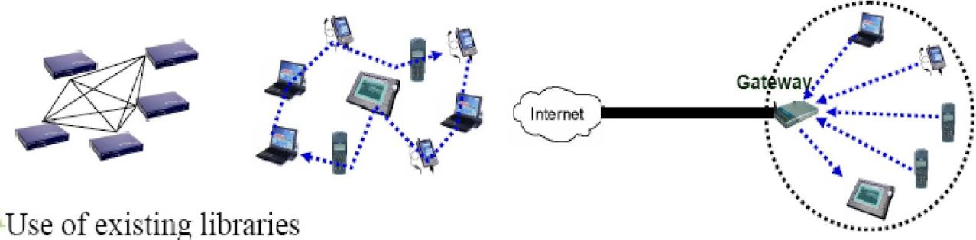
- Demo1

- Demo3
- Tcl-level of NS-2 knowledge is enough to play with existing functionalities.

- Extending NS-2
  - NS-2 is a computer program written in Tcl/OTcl and C/C++, which means you can extend the program as much as you want.
  - OTcl, C/C++-level understanding of NS-2 is prerequisite. Understanding OTcl/C++ linkage is also required.
- Contributing your eﬀort to NS-2 society
  - You can also contribute your codes to the NS-2 society.
  - No computational intelligence package!

Limitation of NS-2
- NS-2 is a “simulator” of which model is necessarily a simplification of the realworld system. e.g. The simulator model for Reno, NewReno, Sack, and Fack TCP are supported;however, there is no dynamic window advertisement, SYN/FIN connection establishment/teardown. Segment and ACK number computations are in units of
packets.
- NS-2 is not a polished and finished product, rather the result of an on-going eﬀort of research and development. Bugs in the software are still being discovered and corrected. Therefore, it is YOUR responsibility to validate correctness of the
simulation results.
- e.g. EDCF semi-package for 802.11e has/had timing bugs for 802.11a PHY.
(Atheros EDCF semi-package ns-06010 is developed from ns-2.1b7snapshot 20000808)
- Nevertheless, NS-2 is quite popular; more than hundreds of papers using NS-2 for research can be found in IEEE Xplore.

Practical - 2
Aim: Network Simulator installation of wireless sensor network using NS2

Installing NS-2 on the Linux
Requirement for installing NS-2
- a Unix mounted computer, a C++ compiler, 320MB space.
- NS-2 is developed on several kinds of Unix such as FreeBSD, Linux, and Solaris.
- You can run NS-2 on windows if Linux emulator, cygwin, is installed.
- Cygwin is a Linux-like environment for Windows. It consists of two parts:
A DLL (cygwin1.dll) which acts as a Linux API emulation layer providing substantial Linux API functionality. A collection of tools, which provide Linux look and feel.
- The cygwin install is still considered EXPERIMENTAL.
- There are two ways to install NS-2, suggested by NS development team.
- Install from the pieces.
- Install from the all-in-one package.
- NS-2 installation with all-in-one package.
- We will install ns-allinone-2.29 onto a Debian Linux machine.
- To install NS-2 on Windows+cygwin, please refer to
http://nsnam.isi.edu/nsnam/index.php/Running_Ns_and_Nam_Under_Windows_9x/2000
/XP
Installing ns-allinone-2.29 onto a Debian Linux machine.
We’ll use remote-terminal client programs to access the Linux workstation. The installation procedure is identical when you install on your own Linux machine except you don’t use the client programs such as putty, X-Win32, and WinSCP3.
- step 1. download ns-allinone package from the official NS-2 website.
- step 2. log into the Linux server, wunsch-linux.ece.umr.edu, using putty+X-Win32
- step 3. upload the file to your home directory, /home/ns2userName, on the server, using a FTP client such as WinSCP3.
- step 4. untar (uncompress) the uploaded file $ tar xzvf ﬁlename
- step 5. Change directory to the ns-allinone directory, run the installation script, an wait until the installation is completed and successful. If the installation is
not successful, you should ask the ns-mailinglist or fix the bug by yourself.
$ cd ~/ns-allinone-2.29
$ ./install
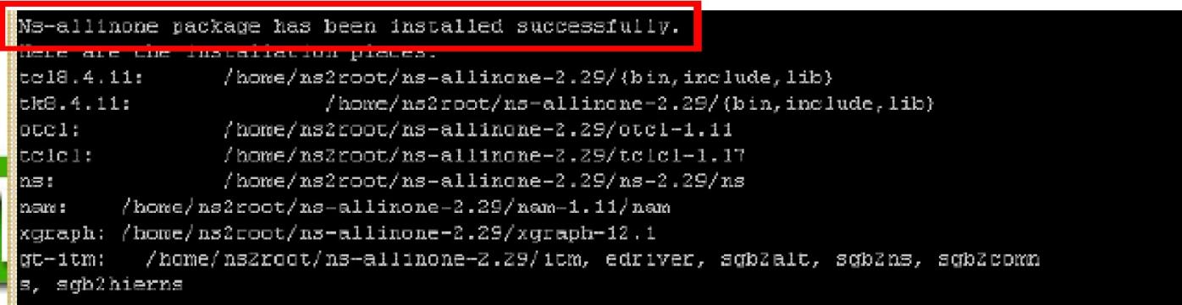

- step 6. Configure your .bashrc file in the home directory to use NS-2.
.bashrc is a configuration file for bash where rc stands for “run commands”
$ cd ~ or cd /home/ns2userName
$ gedit .bashrc &
To configure your .bashrc file, go to the last line of the .bashrc and add the path of the NS-2 executable ns and tcl, LD_LIBRARY_PATH, and TCL_LIBRARY.
For example,
# …In your .bashrc
# ns-allinone-2.29. This line is a comment using the # character.
export PATH="$PATH:/home/ns2userName/ns-allinone-2.29/bin:/home

/ns2userName/ns-allinone-2.29/tcl 8.4.11/unix:/home/ns2userName/ns-allinone- 2.29/tk8.4.11/unix"
export LD_LIBRARY_PATH="/home/ns2userName/ns-allinone-2.29/otcl-1.11,
/home/ns2userName/ns-alli none-2.29/lib"
export TCL_ LIBRARY="/home/ns2userName/ns-allinone-2.29/tcl8.4.11/library"

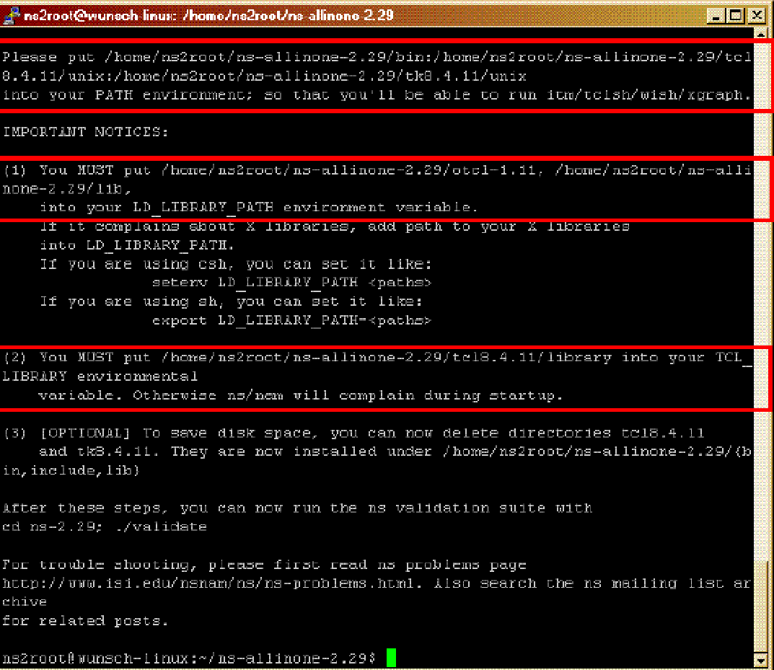
- The precise directories are found at the end of the installation messages.

- step 7. Exit the current terminal, run a new terminal, and check if the new .bashrc works.
$ exit
$ ns ; # At the home directory in a new terminal
%
If the path setup is correct, you’ll see %. Otherwise, bash: ns: command not foun
  - step 8. (optional) Run an example Tcl script with X-Win32 turned on to test if NS works properly.
$ cd ~/ns-allinone-2.29/ns-2.29/tcl/ex
$ ns simple.tcl 210
0.0037499999999999999
running nam...

  - step 9. (optional) Go to the NS directory and validate the installation.Be aware that this validation process takes much longer than installation.
$ cd ~/ns-allinone-2.29/ns-2.29
$./validate
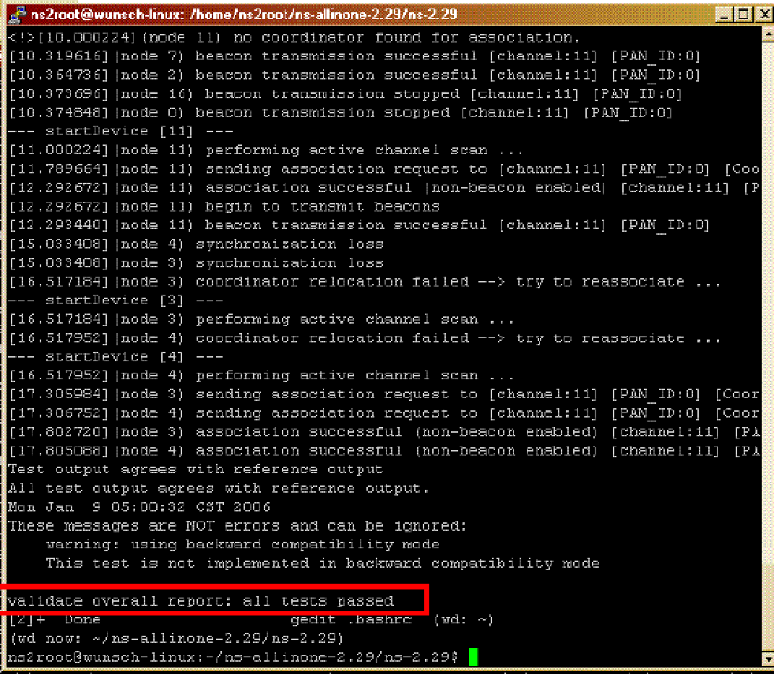

More on .bashrc setup for NS-2
- Bash shell is the most popular shell and .bashrc is a configuration file for
bash. .bashrc follows the syntax for (bash) shell script. Even if the 1st line of a shell script starts from #!/bin/bash, .bashrc does not start from the line.
- The variable information the shell maintains is called the shell’s environment where variables are chunks of computer memory that hold changeable values.
- export variable is a command to make a variable an environment variable, which is global to shell and subshells. var=value defines a variable. For
example, export name=“kuna” assigns kuna to the variable name and make the variable an environment variable. Note: no space around the equal sign “=“.
- PATH is one of the standard shell variables, holding the search path for commands. The list of directories is separated by colon “:”.
- Bash uses the $ character that substitution needs to be made. “$” is used in th script to access the value of a variable. Therefore $PATH returns the value in
the environment variable PATH. You can see the current value of PATH. Try,

$ echo $PATH
- The # character comments the rest of the line.
- LD_LIBRARY_PATH and TCL_ LIBRARY are environment variables showing the paths to the libraries. Execution of NS requires the libraries.
- The .bashrc configuration for NS-2 revisited. In .bashrc, the following lines shoul be added, typically, at the end of the file.
# ns-allinone-2.29. This line is a comment using the # character. export
PATH="$PATH:/home/ns2userName/ns-allinone-2.29/bin:/home/ns2userName/nsallinone- 2.29/tcl 8.4.11/unix:/home/ns2userName/ns-allinone-2.29/tk8.4.11/unix"
export LD_LIBRARY_PATH="/home/ns2userName/ns-allinone-2.29/otcl-1.11,
/home/ns2userName/ns-alli none-2.29/lib"
export TCL_ LIBRARY="/home/ns2userName/ns-allinone-2.29/tcl8.4.11/library"
Q: What’s gonna happen if a path LD_LIBRARY_PATH isn’t set up properly?
A: If you run NS by typing, $ ns <tcl_script> , you’ll see an error message such as
$ ns :error in loading shared libraries : libtk8.3.so : can not open shared
$ object ﬁle : no suchﬁle or directory
From http://mailman.isi.edu/pipermail/ns-users/2000-November.txt

Practical - 3
Aim : Write TCL script for transmission between mobile nodes using NS2.

Code:
# Create a simulator object set ns [new Simulator]

# Define diﬀerent colors
# for data ﬂows (for NAM)
$ns color 1 Blue
$ns color 2 Red

# Open the NAM trace file set nf [open out.nam w]
$ns namtrace-all $nf

# Define a 'finish' procedure proc finish {} {
global ns nf
$ns ﬂush-trace

# Close the NAM trace file close $nf

# Execute NAM on the trace file exec nam out.nam &
exit 0
}

# Create four nodes set n0 [$ns node] set n1 [$ns node] set n2 [$ns node] set n3 [$ns node]

# Create links between the nodes
$ns duplex-link $n0 $n2 2Mb 10ms DropTail
$ns duplex-link $n1 $n2 2Mb 10ms DropTail
$ns duplex-link $n2 $n3 1.7Mb 20ms DropTail

# Set Queue Size of link (n2-n3) to 10
$ns queue-limit $n2 $n3 10

# Give node position (for NAM)
$ns duplex-link-op $n0 $n2 orient right-down
$ns duplex-link-op $n1 $n2 orient right-up
$ns duplex-link-op $n2 $n3 orient right

# Monitor the queue for link (n2-n3). (for NAM)
$ns duplex-link-op $n2 $n3 queuePos 0.5

# Setup a TCP connection

set tcp [new Agent/TCP]
$tcp set class_ 2
$ns attach-agent $n0 $tcp

set sink [new Agent/TCPSink]
$ns attach-agent $n3 $sink
$ns connect $tcp $sink
$tcp set fid_ 1

# Setup a FTP over TCP connection set ftp [new Application/FTP]
$ftp attach-agent $tcp
$ftp set type_ FTP

# Setup a UDP connection set udp [new Agent/UDP]
$ns attach-agent $n1 $udp set null [new Agent/Null]

$ns attach-agent $n3 $null
$ns connect $udp $null
$udp set fid_ 2

# Setup a CBR over UDP connection set cbr [new Application/Traffic/CBR]
$cbr attach-agent $udp
$cbr set type_ CBR
$cbr set packet_size_ 1000
$cbr set rate_ 1mb
$cbr set random_ false

# Schedule events for the CBR and FTP agents
$ns at 0.1 "$cbr start"
$ns at 1.0 "$ftp start"
$ns at 4.0 "$ftp stop"
$ns at 4.5 "$cbr stop"

# Detach tcp and sink agents # (not really necessary)
$ns at 4.5 "$ns detach-agent $n0 $tcp ; $ns detach-agent $n3 $sink"

# Call the finish procedure after # 5 seconds of simulation time
$ns at 5.0 "finish"

# Print CBR packet size and interval
puts "CBR packet size = [$cbr set packet_size_]" puts "CBR interval = [$cbr set interval_]"

# Run the simulation
$ns run

Output:

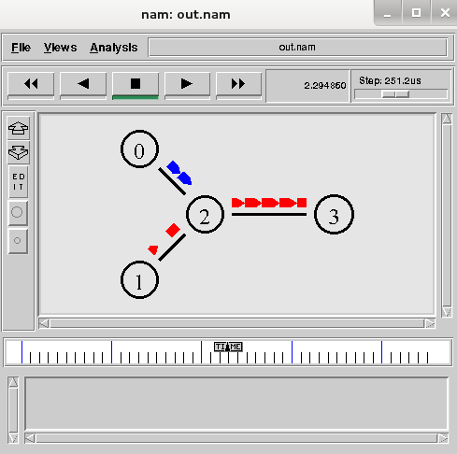

Practical -4
Aim : Write TCL script for sensor nodes with diﬀerent parameters using NS2.

#create a new simulator object ns set ns [new Simulator]

# creation of two nodes n0 and n1
set n0 [$ns node] set n1 [$ns node]

#Open the files for tracing in write mode, if the file already exits, it will be overwritten, else a #new file will be created

set tracefile [open out.tr w]
$ns trace-all $tracefile
#Open the files for network animation set namfile [open out.nam w]
$ns namtrace-all $namfile

#Create a duplex link between nodes n0 and n1
$ns duplex-link $n0 $n1 2MB 10ms DropTail #Creates TCP Agent and attach it to node 0 set tcp0 [new Agent/TCP]
$ns attach-agent $n0 $tcp0
#creates TCP Sink Agent and attach that agent to node 1 set tcpsink0 [new Agent/TCPSink]
$ns attach-agent $n1 $tcpsink0

# Set the Traffic for FTP and attach it to TCP Agent set ftp [new Application/FTP]
$ftp attach-agent $tcp0

#connect the source and the sink

$ns connect $tcp0 $tcpsink0 #Start the traffic at 1.0seconds.
$ns at 1.0 "$ftp start"

#call the finish procedure at 4.0 sec

$ns at 4.0 "finish" #Procedure finish{} proc finish {} {
global ns tracefile namfile
exec nam out.nam &; #execute the animation within the procedure exit 0
}

Practical -5
Aim : Network Toplology creation and REST API introduction

This is a straight-forward task and you can even build your own topology if you want
(mininet.org quick walk through here), but this is the topology I will use and maybe you
should follow for the first time so that all the examples of curl/REST API in the next steps match on the IP/ﬂow level.
Here is the mininet launch script that I am using to launch my lab (just create a file in your mininet VM “double_star.py” and make it executable), I think just by looking at it it is quite clear what these lines achieve and also how you should edit it if you want new switch or a host:
#!/usr/bin/python

from mininet.topo import Topo from mininet.net import Mininet
from mininet.node import Node , Controller, RemoteController,
OVSSwitch
from mininet.log import setLogLevel, info from mininet.cli import CLI
from mininet.util import irange from mininet.link import TCLink
c0=RemoteController( 'c0', ip='192.168.125.9' ) class NetworkTopo( Topo ):
"A simple topology of a double-star access/dist/core."

def build( self ):

h1 = self.addHost( 'h1', ip='10.10.2.1/24', defaultRoute='via 10.10.2.254' )
h2 = self.addHost( 'h2', ip='10.10.2.2/24', defaultRoute='via 10.10.2.254' )
h3 = self.addHost( 'h3', ip='10.10.2.3/24', defaultRoute='via 10.10.2.254' )
h4 = self.addHost( 'h4', ip='10.10.2.4/24', defaultRoute='via 10.10.2.254' )
h5 = self.addHost( 'h5', ip='10.10.2.5/24', defaultRoute='via 10.10.2.254' )
h6 = self.addHost( 'h6', ip='10.10.2.6/24', defaultRoute='via 10.10.2.254' )
g1 = self.addHost( 'g1', ip='10.10.2.254/24')

s1 = self.addSwitch( 's1', dpid='0000000000000001',protocols='OpenFlow13' )
s2 = self.addSwitch( 's2', dpid='0000000000000002',protocols='OpenFlow13' )
s3 = self.addSwitch( 's3', dpid='0000000000000003',protocols='OpenFlow13' )
s4 = self.addSwitch( 's4', dpid='0000000000000004',protocols='OpenFlow10' )
s5 = self.addSwitch( 's5', dpid='0000000000000005',protocols='OpenFlow13' )
s6 = self.addSwitch( 's6',

dpid='0000000000000006',protocols='OpenFlow13' )

#core
self.addLink ( s1, s2 )

#distribution self.addLink ( s1, s3 ) self.addLink ( s1, s4 ) self.addLink ( s1, s5 ) self.addLink ( s1, s6 )

self.addLink ( s2, s3 ) self.addLink ( s2, s4 ) self.addLink ( s2, s5 ) self.addLink ( s2, s6 )

#acccess
self.addLink( s3, h1 ) self.addLink( s3, h2 ) self.addLink( s4, h3 ) self.addLink( s4, h4 ) self.addLink( s5, h5 ) self.addLink( s5, h6 ) self.addLink( s6, g1)

def run():
topo = NetworkTopo()
net = Mininet( topo=topo, controller=c0 ) net.start()

CLI( net ) net.stop()

if name == ' main ': setLogLevel( 'info' ) run()

Step 1) Checking your HP SDN VAN controller running your LAB
In this step, we will check that you can access the controller and we see the mininet topology and more importantly we will disable the controller running in hybrid mode as that will create a loop/broadcast storm in our mininet by default if we do not disable this
(explanation below).
Login to your SDN controller in your lab is simply going to https://192.168.125.9:8443/sdn/ui/ (accept the self-signed certificate warning)
Inside, check if all six switches are in the in the OpenFlow Monitor and the topology is visible inside the OpenFlow Topology:

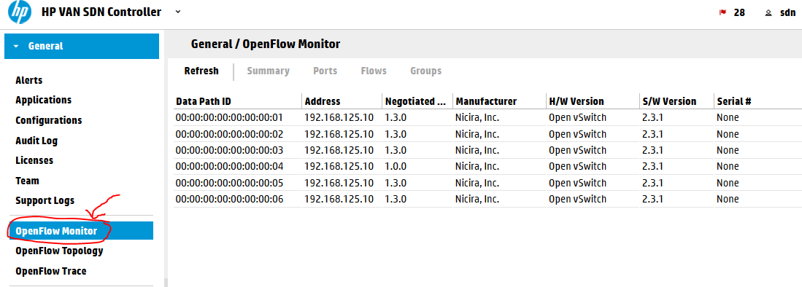
HP
VAN SDN Controller 2.4.6 OpenFlow Monitor view
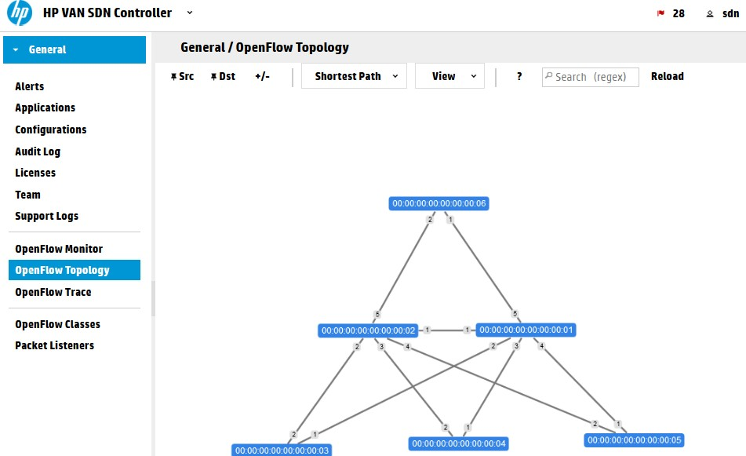 HP
VAN SDN Controller 2.4.6 OpenFlow Topology view

Explanation: Hybrid mode is a mode where the controller will leave the forwarding logic on
the switches and will only care on extra features (like QoS or security). It is a great trick if you want to remain using your traditional fowrarding (including spanning-tree) and only focus on new SDN features, but it has a drawback. In this mode the controller will push a simple “Forward ANY: NORMAL” command to all switches which will tell them that by default all
traffic should be simply forwarded by traditional means … this is conﬂict with the fact that
tha Open vSwitch we are running doesn’t have spanning-tree protocol and our topology has many loops. … so yes, it is a broadcast storm prone … The fact is that HP is selling this technology and by default expecting HP switches that can also run in hybrid mode, which
means that you would have SDN for all special features, but will still run spanning tree to avoid loops. It is actually very eﬀective with MSTP and IRF technology that HP has that will not really block any port and will lower the processing of the SDN controller in production network, but it is not a pure SDN forwarding that we want to play with in our LAB now. So

we will disable hybrid mode and force the SDN controller to take full responsibility on ALL forwarding decisions. You can check any switch Flow table before and after this change to see that the default rule pushed to the switches will change from default “forward: NORMAL” to “forward: Controller”. The forward: Controller means that if there is new packet that is not matching any existing rule, send this packet to controller for analysis.
To disable this mode, go to Configurations -> ControllerManager and modify the
hybrid.mode ﬂag to false via the Modify button at the top. All switches will disconnect and reconnect once you apply this.

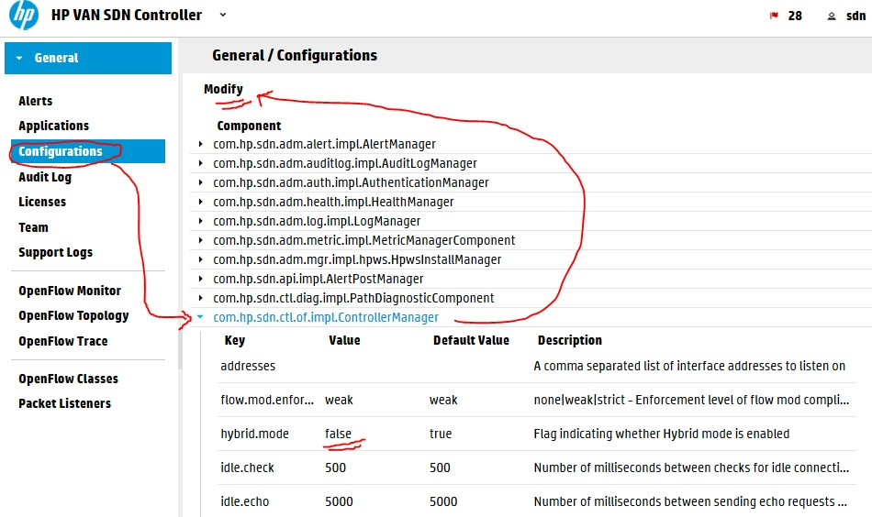
HP
VAN SDN Controller 2.4.6 – disabling hybrid mode

Following getting rid of the hybrid mode, let’s check the forwarding, mininet has one great command called “pingall” that will check connectivity between all the hosts created in the mininet topology, run it in the mininet> commandline, sucessfull output looks like this: mininet> pingall
*** Ping: testing ping reachability
g1 -> h1 h2 h3 h4 h5 h6 h1 -> g1 h2 h3 h4 h5 h6 h2 -> g1 h1 h3 h4 h5 h6 h3 -> g1 h1 h2 h4 h5 h6 h4 -> g1 h1 h2 h3 h5 h6 h5 -> g1 h1 h2 h3 h4 h6 h6 -> g1 h1 h2 h3 h4 h5
*** Results: 0% dropped (42/42 received)

Now look at the topology view again and all the hosts that appeared:

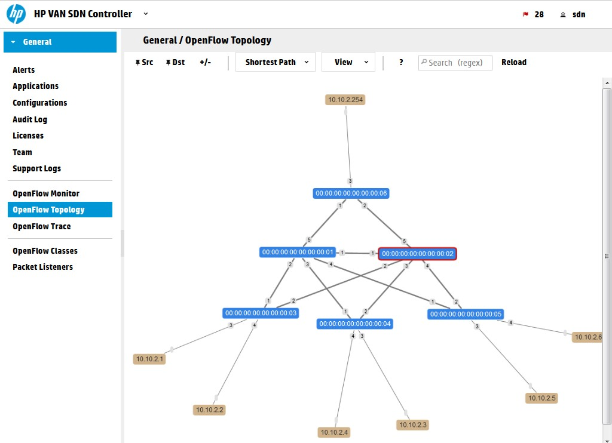
HP
VAN SDN Controller 2.4.6 – all lab nodes appeared
And also if you now go to OpenFlow monitor, select a switch and view its ﬂow tables, there is going to be a lot of rules there now all doing point-to-point IP rules to guide the ICMP
packets to their destinations.

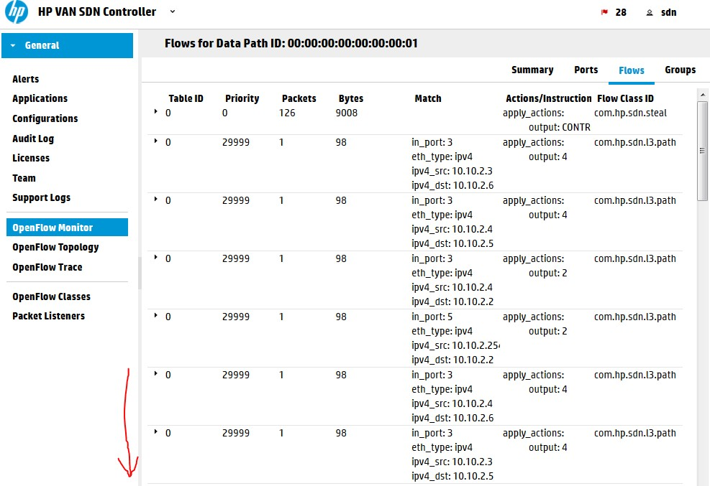
HP
VAN SDN Controller 2.4.6 – ﬂow tables for ping without hybrid mode

Last thing to learn before we continue is to know the OpenFlow topology view ability to show you a patch for a specific packet. Wait for a few seconds for the ICMP ﬂows to timeout from the tables before continuing. Open this view and at the top change “SPF” to “Follow
Flow”, now we are going to see how at this moment the switches would forward a traffic from H1 (10.10.2.1) to G1 (10.10.2.254). Enter into the table “Abstract Packet” the source and destination IPs of these hosts, or click on them and select them as SRC/DST with the
buttons above. This is what will happen, note that the red lines are not showing any path at this moment! This is because this function is not asking the controller, but it is asking the switches and checking their ﬂow tables, but because the icmp ﬂows already timeout.

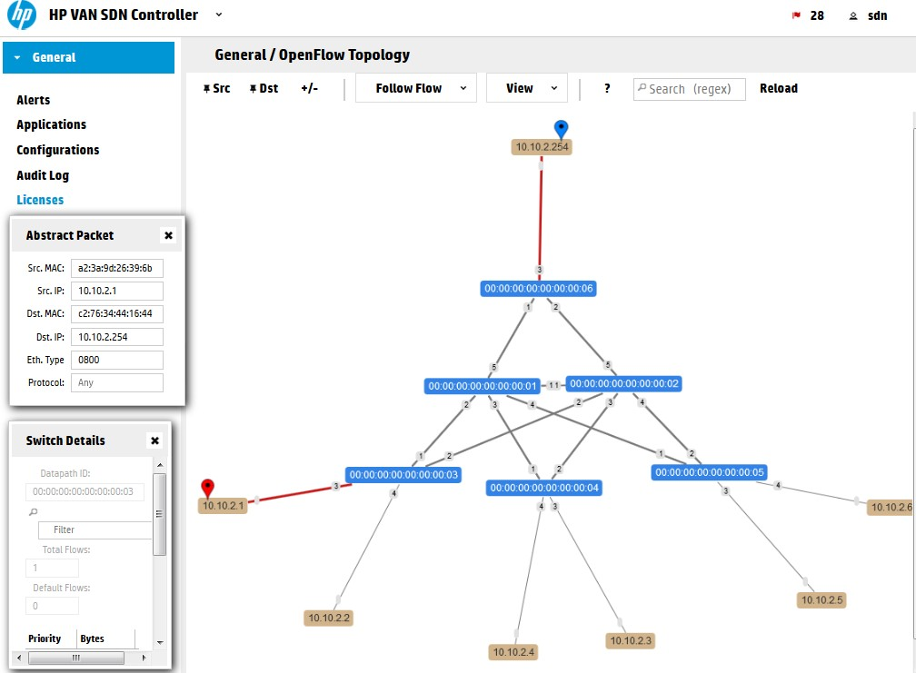
HP
VAN SDN Controller 2.4.6 – no path yet in OpenFLow
Lets do something more interesting now compared to ping. Mininet has a small HTTP server available, so we will make G1 a server and H1 will to to G1 with HTTP request. These are the two commands to do this simply and verify the controller can also forward TCP traffic and
not only pings.

mininet> g1 python -m SimpleHTTPServer 80 & mininet> h1 wget 10.10.2.254
--2015-05-19 06:18:11-- http://10.10.2.254/
Connecting to 10.10.2.254:80... connected. HTTP request sent, awaiting response... 200 OK Length: 942 [text/html]
Saving to: index.html

100%[======================================>] 942 --.-K/s
in 0.03s

2015-05-19 06:18:11 (36.0 KB/s) - index.html saved [942/942]

Now have a look again in the topology view:

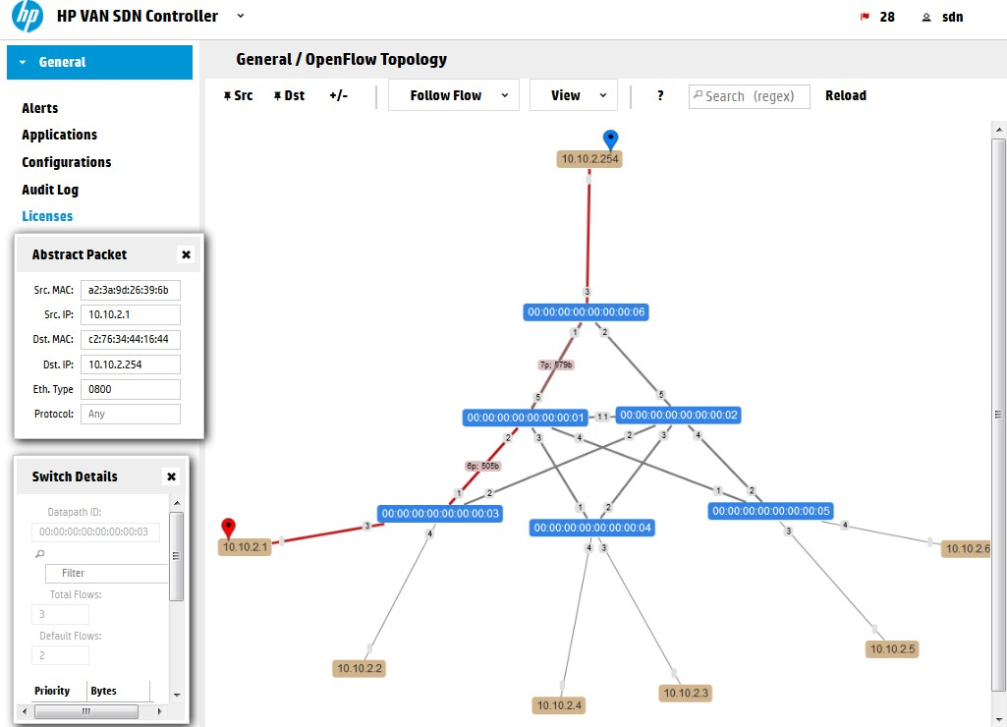
HP VAN SDN Controller 2.4.6 – path between G1 and H1
Remember this approach because we are going to use this soon below to see how we will manipulate this path with a few curl calls.

Step 2) Introduction to the REST API
Ok, we have a working topology, working controller, now lets see what is the REST API I mentioned….
Open your browser and go to your controller REST API interface, you should see something like this and feel free to click around:

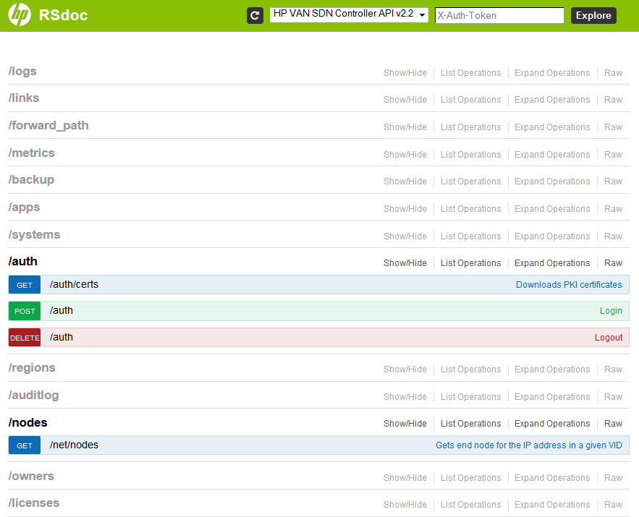
HP
VAN SDN Controller 2.4.6 – REST API main page
What you see is the REST API way to self-document itself a little. These sections are both
trying to explain you what they can do for you and also give you a way to try them directly in this web interface without writing any app (this also help the development process very
much!).
But first we need to authenticate ourselves to this interface! This is how to do it:
- Open the /auth section
- Opent the POST method /auth, these methods are HTTP “POST” methods for entering data via REST API
- And write this text to the field (update the “sdn” username and “skyline” password if you are not using the defaults) and hit “Try it out!” button:
{"login":{"user":"sdn","password":"skyline","domain":"sdn"}}
NOTE: The format we have entered is called JSON and it is a structured key/value list that I believe will become very familiar to you very soon once you see it in a structured way.
This should be the result, note the Response Code should be 200 and in the Response Body we are looking for the “token” value:

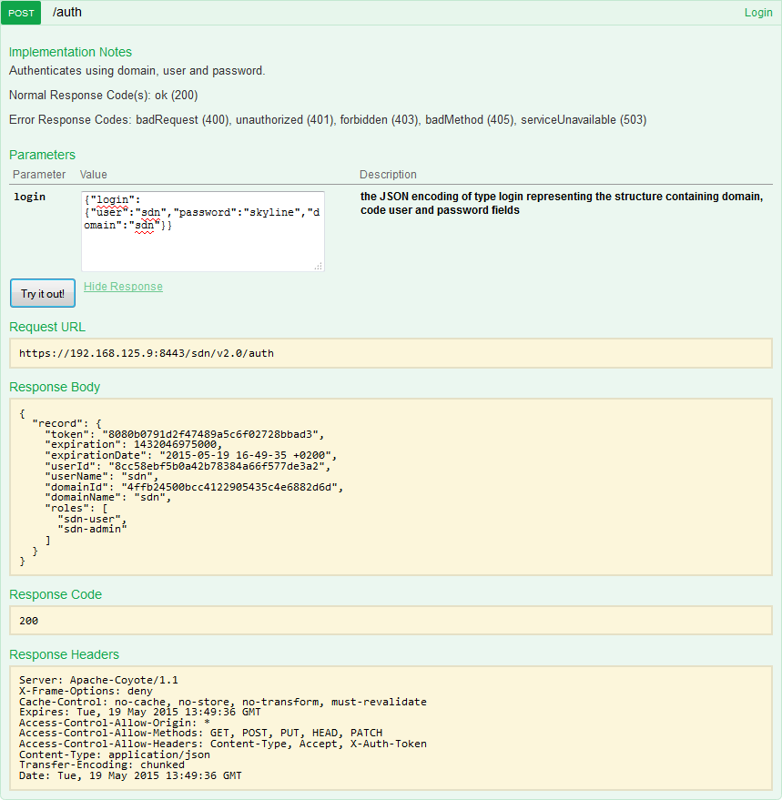
HP
VAN SDN Controller 2.4.6 – REST API authentication success and receiving the auth token
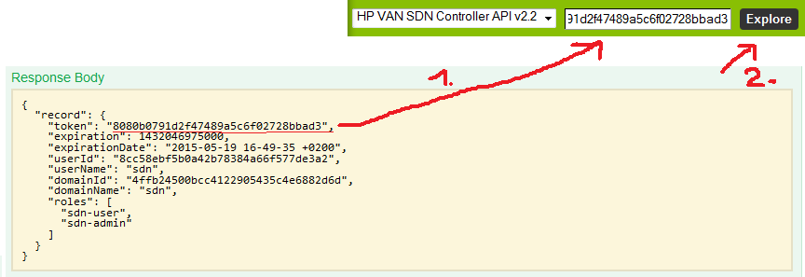
Now, take the token and enter it to the top formular on this REST API page and hit “Explore” to have your full session authorized for all the other REST APIs we are going to check next:
HP VAN SDN Controller 2.4.6 – REST API authentication token included in the whole API

Step 3)Getting list of switches, list of end-nodes and ﬂow tables via REST API
With this token now included, I encourage you to explore yourself at least these three sections:

/nodes
/nodes – gives you a JSON list of all the end hosts that were recently active in the network. So in this example only the H1 and G1 hosts are shown:

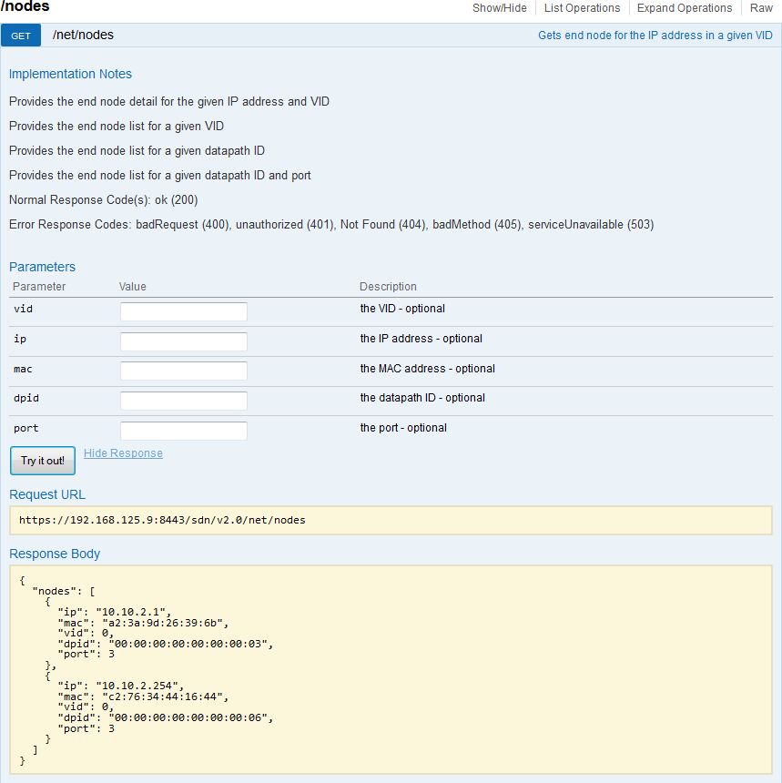
HP
VAN SDN Controller 2.4.6 – REST API list of /nodes

/devices
/devices – gives you a list of all switches that are currently active (those with “Online”) but
also switches that were historically used and are no longer registered (controller remembers them as Oﬄine even across reboots). The most important attribute there is the uid
identification that we will be using in the ﬂow table next.

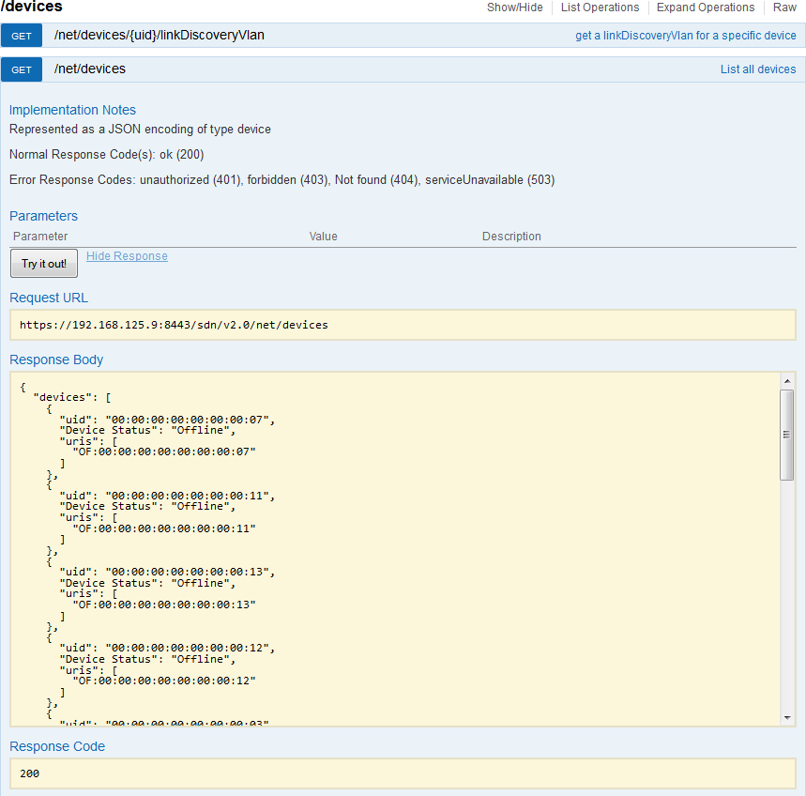
HP
VAN SDN Controller 2.4. r switches

/of/datapath/{dpid}/ﬂows
/of/datapath – holds the ﬂow forwarding information, the basic ﬂow table can be retrieved here by asking for a ﬂow table of individual switch via the {dpid} (or uid from the previous
/devices). Here is an example how we exported ﬂow table from the switch s3, that has dpid of “00:00:00:00:00:00:00:03”.

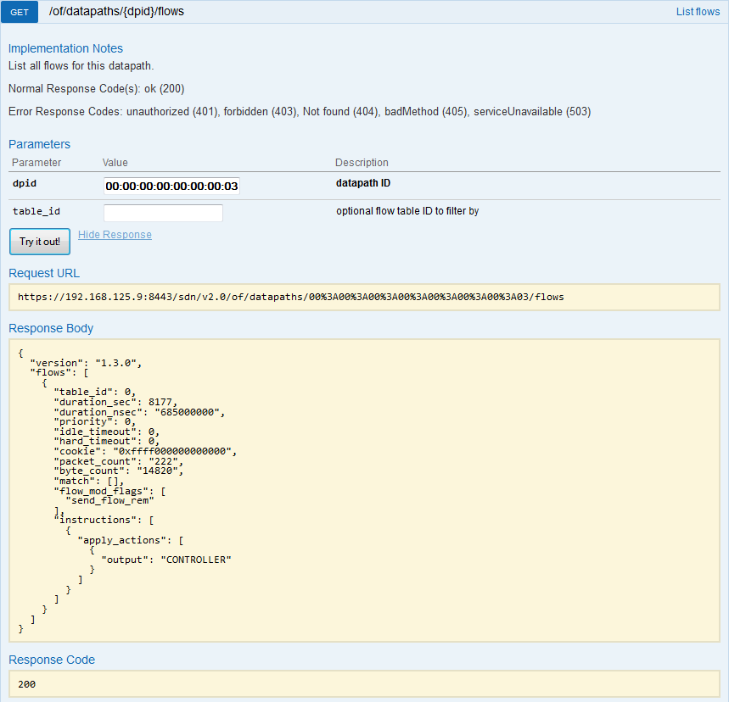
HP VAN SDN Controller 2.4.6 – REST API list of ﬂows defined for switch S3 by dpid of 00:00:00:00:00:00:00:03

Practical - 6
Aim : Inﬂuencing ﬂows via cURL commands

Step 1) cURL command line tool to authenticate to the REST API and receive a token
Lets start with the basics, in linux console exists a utility command “curl” that we will use.
The command to send basic JSON structure with username/password to the controller /auth in REST API is as follows:
$ curl -k -H 'Content-Type:application/json' \

-d'{"login":{"user":"sdn","password":"skyline","domain":"sdn"}
}' \
https://192.168.125.9:8443/sdn/v2.0/auth

Explanation:
  - -k: Allow connections to SSL sites without certs (H) , we need this because of the self-signed certificate used by default
  - -H: This parameter enables adding information to the HTTP header, we need to insert here that the content of this HTTP header is going to be a JSON data structure
  - -d: This parameter is giving cURL the content to add to the content of this HTTP request.
  - [url]: Every curl rrequest needs a URL where to send it, in our case notice that the URL is the SDN REST API URL that you know from the previous part of this tutorial

$ sudo apt-get install curl

How should the output look-like? This is what you should probably get when you execute this command on the LAB environment:
# curl -sk -H 'Content-Type:application/json' \

-d'{"login":{"user":"sdn","password":"skyline","domain":"sdn"}
}' \
https://192.168.125.9:8443/sdn/v2.0/auth

Outcome:
{"record":{"token":"ca6f17e6e47946eb9fccba74493de371","expirat ion":1432050428000,"expirationDate":"2015-05-19 17-47-08
+0200","userId":"8cc58ebf5b0a42b78384a66f577de3a2","userName":

"sdn","domainId":"4ffb24500bcc4122905435c4e6882d6d","domainNam e":"sdn","roles":["sdn-user","sdn-admin"]}}

Uﬀ, … what a mess. This is not really readable, so lets try to format it a little better. We can
using the python json library command python -mjson.tool that takes the STDIN and formats it in a human readable way. So again, just note that I have added a pipeline at the end with
the python at the end.
# curl -sk -H 'Content-Type:application/json' \

-d'{"login":{"user":"sdn","password":"skyline","domain":"sdn"}
}' \
https://192.168.125.9:8443/sdn/v2.0/auth \
| python -mjson.tool

Outcome:
{
"record": {
"domainId": "4ffb24500bcc4122905435c4e6882d6d", "domainName": "sdn",
"expiration": 1432050873000,
"expirationDate": "2015-05-19 17-54-33 +0200", "roles": [
"sdn-user", "sdn-admin"
],
"token": "53c50d119559431e9dd555d1c7cb916c", "userId": "8cc58ebf5b0a42b78384a66f577de3a2", "userName": "sdn"
}
}

Much better! Now you can see that we have again received a “token” that is a value we are going to need with all the following cURL requests to other parts of the REST API. So, lets make this a little bit more easy, lets have this command to only extract the token value and add it to a global variable in bash (which should be your default ubuntu command line, if
not, enter bash command to activate it).
First let’s filter the token value from all the other stuﬀ. I will do it the old fashion way with grep/tr/cut commands. The command is now this:
curl -sk -H 'Content-Type:application/json' \

-d'{"login":{"user":"sdn","password":"skyline","domain":"sdn"}
}' \
https://192.168.125.9:8443/sdn/v2.0/auth \
| python -mjson.tool \
| grep "token" \
| tr -d [:space:] \
| tr -d "\"," \
| cut -d ":" -f 2

Explanation:
  - grep – command to filter only lines of STDIN where a given string is present
  - tr – truncate command that replaces all appearances of one letter from source string with another letter, in this case we used it twice, once to remove white spaces and second time to clear quotation marks and comma sign.
  - cut – this tool is used to cut a certain words from a single line STDIN (imagine grep, but vertical) with the deminator of “:” and we want the second column
.
Outcome:
2c8bbb5ac2db4162a2f95a064706dcc4

Cool, I now only have a quick script to get the value. So lets just export it to a file in /tmp directory in bash shell so that all our next scripts can use this without asking the controller for it again, but for this, lets start making this as a bash script so open your favorite editor and write this into the file:
#add our token to the variable "token"
token=`curl -sk -H 'Content-Type:application/json' \

-d'{"login":{"user":"sdn","password":"skyline","domain":"sdn"}
}' \
https://192.168.125.9:8443/sdn/v2.0/auth \
| python -mjson.tool \
| grep "token" \
| tr -d [:space:] \
| tr -d "\"," \
| cut -d ":" -f 2`;

echo "This is the token recoeved $token,";
echo "will place it in /temp/SDNTOKEN file for later use."; echo "$token" > /tmp/SDNTOKEN

Step 2) Retrieving some basic information via cURL (nodes/devices/ﬂows)
Identically as in the previous part1 of this series where we retrieved this directly in the REST API web interface, the most important information that we are interested in are the list of switches, list of active nodes and ﬂows from a particular switch.

/nodes – retrieving list of end nodes via cURL
The curl command for this looks as follows, it is using the token holding file from previous script and queries the controller for the nodes.
curl -sk -H "X-Auth-Token:`cat /tmp/SDNTOKEN`" \
-H "Content-Type:application/json" \ https://192.168.125.9:8443/sdn/v2.0/net/nodes \
| python -mjson.tool

Explanation:
The only diﬀerence here is that we are adding two header lines with two “-H” parameters, one for declaring that the content is to be JSON format and the second is adding the
- Auth-Token parameter with the inclusion of the token from the /tmp/SDNTOKEN file we created previously.
Outcome:
{
"nodes": [
{
"dpid": "00:00:00:00:00:00:00:03",
"ip": "10.10.2.1",
"mac": "a2:3a:9d:26:39:6b",
"port": 3,
"vid": 0
},
{
"dpid": "00:00:00:00:00:00:00:06",
"ip": "10.10.2.254",
"mac": "c2:76:34:44:16:44",
"port": 3,
"vid": 0
}
]
}

/devices – retrieving a list of switches via cURL
This is again the cURL command to use:
curl -sk -H "X-Auth-Token:`cat /tmp/SDNTOKEN`" \

-H "Content-Type:application/json" \ https://192.168.125.9:8443/sdn/v2.0/net/devices \
| python -mjson.tool

Outcome:
{
"devices": [
{
"Device Status": "Online",
"uid": "00:00:00:00:00:00:00:03",
"uris": [
"OF:00:00:00:00:00:00:00:03"
]
},
{
"Device Status": "Offline", "uid": "00:00:00:00:00:00:00:10",
"uris": [
"OF:00:00:00:00:00:00:00:10"
]
},
{
"Device Status": "Offline", "uid": "00:00:00:00:00:00:00:14",
"uris": [
"OF:00:00:00:00:00:00:00:14"
]
},
{
"Device Status": "Online",
"uid": "00:00:00:00:00:00:00:06",
"uris": [
"OF:00:00:00:00:00:00:00:06"
]
},
{
"Device Status": "Offline", "uid": "00:00:00:00:00:00:00:09",
"uris": [
"OF:00:00:00:00:00:00:00:09"
]
},
{
"Device Status": "Online",

"uid": "00:00:00:00:00:00:00:01",
"uris": [
"OF:00:00:00:00:00:00:00:01"
]
},
{
"Device Status": "Offline", "uid": "00:00:00:00:00:00:00:08",
"uris": [
"OF:00:00:00:00:00:00:00:08"
]
},
{
"Device Status": "Online",
"uid": "00:00:00:00:00:00:00:04",
"uris": [
"OF:00:00:00:00:00:00:00:04"
]
},
{
"Device Status": "Online",
"uid": "00:00:00:00:00:00:00:05",
"uris": [
"OF:00:00:00:00:00:00:00:05"
]
},
{
"Device Status": "Online",
"uid": "00:00:00:00:00:00:00:02",
"uris": [
"OF:00:00:00:00:00:00:00:02"
]
}
]
}

/of/datapath/{dpid}/ﬂow
This one is more interesting because you need to send the specific switch dpid identification to the cURL request content for REST API to understand which switch you are asking for. But what DPID to choose, this is up to you, I was interested in the ﬂow between H1 and G1 so I manually selected the DPID of S3 that is 00:00:00:00:00:00:00:03 and added it to another
/tmp/SDNDPID file for temporary storage. Then I actually used two commands:
echo "00:00:00:00:00:00:00:03"

> /tmp/SDNDPID
curl -sk -H "X-Auth-Token:`cat /tmp/SDNTOKEN`" \
-H "Content-Type:application/json" \ https://192.168.125.9:8443/sdn/v2.0/of/datapaths/`cat
/tmp/SDNDPID`/flows \
| python -mjson.tool

Outcome:
{
"flows": [
{
"byte_count": "15042", "cookie": "0xffff000000000000", "duration_nsec": "325000000",
"duration_sec": 15396, "flow_mod_flags": [
"send_flow_rem"
],
"hard_timeout": 0,
"idle_timeout": 0, "instructions": [
{
"apply_actions": [
{
"output": "CONTROLLER"
}
]
}
],
"match": [], "packet_count": "225",
"priority": 0,
"table_id": 0
},
{
"byte_count": "1465",
"cookie": "0xfffa000000002328", "duration_nsec": "707000000",
"duration_sec": 1, "flow_mod_flags": [
"send_flow_rem"
],
"hard_timeout": 0,
"idle_timeout": 60,

"instructions": [
{
"apply_actions": [
{
"output": 3
}
]
}
],
"match": [
{
"in_port": 1
},
{
"eth_type": "ipv4"
},
{
"ipv4_src": "10.10.2.254"
},
{
"ipv4_dst": "10.10.2.1"
}
],
"packet_count": "5",
"priority": 29999,
"table_id": 0
},
{
"byte_count": "439",
"cookie": "0xfffa000000002328", "duration_nsec": "660000000",
"duration_sec": 1, "flow_mod_flags": [
"send_flow_rem"
],
"hard_timeout": 0,
"idle_timeout": 60, "instructions": [
{
"apply_actions": [
{
"output": 1
}
]

}
],
"match": [
{
"in_port": 3
},
{
"eth_type": "ipv4"
},
{
"ipv4_src": "10.10.2.1"
},
{
"ipv4_dst": "10.10.2.254"
}
],
"packet_count": "5",
"priority": 29999,
"table_id": 0
}
],
"version": "1.3.0"
}

Step 3) Pushing ﬁrst ﬂow with cURL
Ok, we know how to construct a basic cURL request towards REST API interface to retrieve information, now let’s try to inﬂuence something. I will now switch gear a little and will tell you that we will completely change the route for the H1 host communication with G1 host. First remember the view from previous part of this series that showed the OpenFlow
Topology view from the controller GUI? In your mininet network, ping from H1(10.10.2.1) to G1(10.10.2.254) and check the “Abstract Packet” tracking again like this:

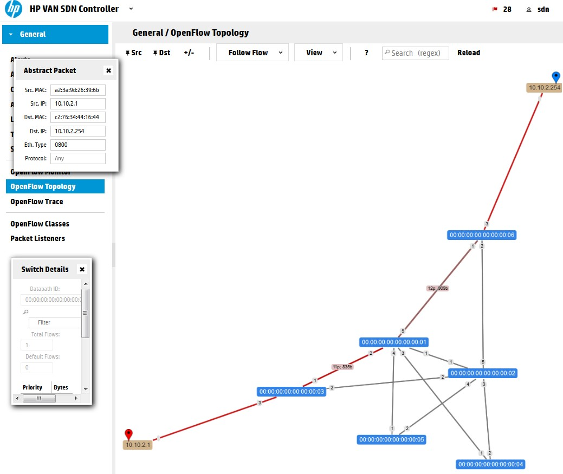
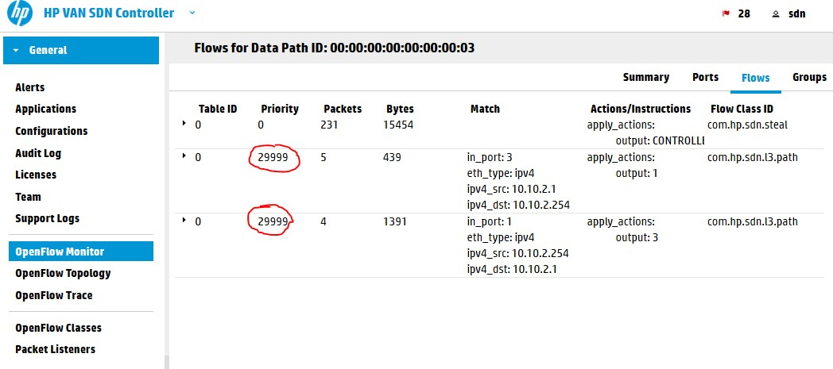
HP VAN SDN Controller 2.4.6 – path between G1 and H1 calculated by the controller alone You can see that the path is using the Shortest Path First (SPF) algorithm that the controller is using to select a path on new traffic. Let’s have a look on the ﬂow table to check how we can override this.
HP VAN SDN Controller 2.4.6 – switch 3 flow table having SPF algorithm rules with priority of 29999

The controller is using rule sin table #0 (which is the default table as OpenFlow 1.3 standard is allowing to have multiple tables and rules jumping between them) and priority of 29999. You can think about priority right now as a form of preference for a request. If there are two rules matching a packet, the one with higher priority will be used. So what we need to do
here is to insert a ﬂow with priority of 30000 to override this.
NOTE: Alternative is that the SPF ﬂows have quite a small idle timer of 60seconds. So if you create your ﬂows with lower priority at the time the SPF rules already timed-out, the switch will not ask the controller for new SPF rules because it already knows what to do with the
packets and will not bother to ask the controller. So feel free to experiment with the priority values and check the behavior of switches.

Constructing the ﬂow JSON data to insert via REST API
Ok, looking at the topology, lets have a simple target that we want to add a ﬂow to switch S3, to push packets for G1/10.10.2.254 destination out of port “2” towards switch S2. This should be easy to do, right? 🙂 What we need is:
  - REST API call for ﬂows inclusion
  - ﬂow JSON structure to enter into this call
  - construct cURL call to push it with HTTP POST method.

- REST API call
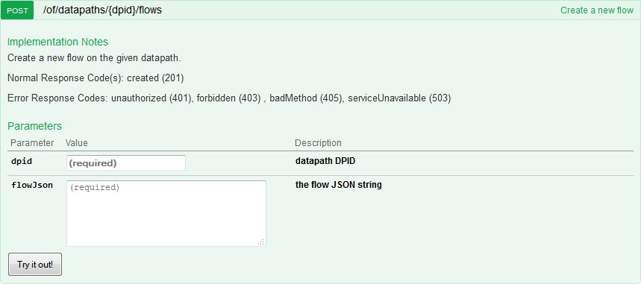
The REST API function that we want to use is /of/datapath/{dpid}/ﬂow, but the POST version which is for inserting (not reading) ﬂows. But when you look at this method, there is no hint how to construct the required “ﬂow” JSON fields:
HP VAN SDN Controller 2.4.6 – REST API for flow insertion

- “ﬂow” JSON deﬁnition
The REST API has one very nice feature and that is that all JSON data models can be viewed in a controller URL: https://192.168.125.9:8443/sdn/v2.0/models

Please note that if you open this in default browser, you will see only a lot of unstructured text, you need a plugin to change this to a readable format. I recommend that you install JSON tools to chrome browser in order to read this in a very easy way:

Once you have them, go to the URL https://192.168.125.9:8443/sdn/v2.0/models with
Chrome and full text search how the “ﬂow” data-structure is defined, it will be looking like this:

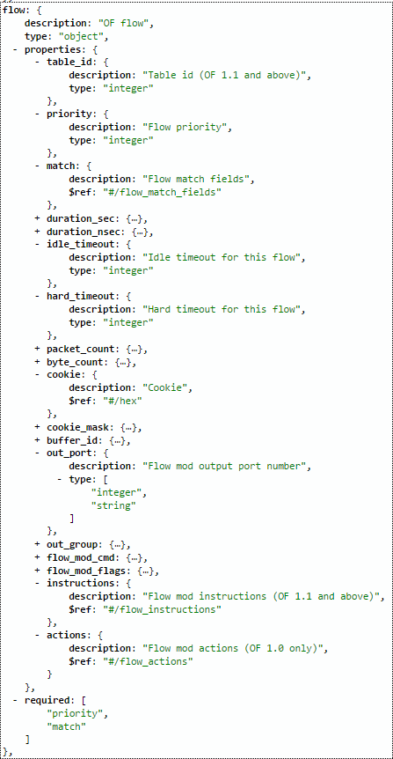
JSON model of “ﬂow”, note the “required” section at the bottom and the fact that OF1.0 used “actions” and OF1.1 and above uses “instructions” and they are not
cross-compatible!
Ok, we have the structure, lets construct the JSON ﬂow for switch S3 dpid:
00:00:00:00:00:00:00:03 , to push traffic from H1 IP: 10.10.2.1 for destination G1 IP:

10.10.2.254 out of port “2”. In addition I want to override the default priority used by the controller so my priority will be 30000 and I am also setting idle and hard timeout values for these rules to make this rule dissapear automatically after 5minutes (Warning: with hard
timeout this will be deleted after 5minutes even if there is active traffic using this rule!). This is there sulting JSON specifically for this (note that I used “instructions” because I have
OpenFlow 1.3 running mininet, if you have OpenFlow 1.0 use “actions” as defined above):
{
"flow": {
"cookie": "0x2031987", "table_id": 0,
"priority": 30000,
"idle_timeout": 300,
"hard_timeout": 300, "match": [
{"ipv4_src": "10.10.2.1"},
{"ipv4_dst": "10.10.2.254"},
{"eth_type": "ipv4"}

2}]}]
}
}
],
"instructions": [{"apply_actions": [{"output":

Explanation:
- cookie – this is a hexa value that you can choose youself, it has no eﬀect on the forwarding, but for me it is usefull later when I will be looking at ﬂowtables to
diﬀerentiate between the ﬂows I have included and ﬂows from other applications. I choosed this value as reference to my birthday 🙂
- table_id – we can have multiple tables, but since we do not require this now, lets use
the default table with ID: 0
- priority – as mentioned, to override default SPF ﬂows with priority 29999, we choose priority of 30000
- idle_timeout – this is a timere that if it reaches 300 seconds will remove the ﬂow, however it gets refreshed with every packet matching this rule, so if the session is active, it will not be removed
- hard_timeout – this timeout is strictly going to reach 300 seconds will remove this rule, ignoring if the traffic is active or not, we will use this now for experiment to avoid the need to manually clean our ﬂows (later I will show how to remove ﬂows via cURL)
- match – this parameter is taking an array as input that is defined by [ ] brackets.
Inside these we will defined the rules for matching this ﬂow. See https://192.168.125.9:8443/sdn/v2.0/models and search for definition of “match”

JSON structure to see all the options, right now we used only the basic ipv4_src and ipv4_dst and defined that we are looking for ipv4 traffic with eth_type.
- instructions – another array defined by [ ] brackets, inside we will have only one
action, which recursivelly also takes an array because one rule can do multiple things with the packet! and by “output”:2 we say that we want the packet to be forwarded out of port 2.

- cURL call to push the new ﬂow
So we have constructed the JSON, if we use the previously showed way of adding JSON to cURL command it would look like this:
curl -ski -X POST \
-H "X-Auth-Token:`cat /tmp/SDNTOKEN`" \
-H "Content-Type:application/json" \
-d '{
"flow": {
"cookie": "0x2031987", "table_id": 0,
"priority": 30000,
"idle_timeout": 300,
"hard_timeout": 300, "match": [
{"ipv4_src": "10.10.2.1"},
{"ipv4_dst": "10.10.2.254"},
{"eth_type": "ipv4"}

2}]}]

}' \
],
"instructions": [{"apply_actions": [{"output":

}

https://192.168.125.9:8443/sdn/v2.0/of/datapaths/00:00:00:00:0 0:00:00:03/flows

Outcome of this command should be code “200 OK” or “201 Created” like shown below:
HTTP/1.1 201 Created Server: Apache-Coyote/1.1 Location:
https://192.168.125.9:8443/sdn/v2.0/of/datapaths/00:00:00:00:0 0:00:00:03/flows
Cache-Control: no-cache, no-store, no-transform, must-revalidate
Expires: Tue, 19 May 2015 18:05:36 GMT

Access-Control-Allow-Origin: *
Access-Control-Allow-Methods: GET, POST, PUT, HEAD, PATCH Access-Control-Allow-Headers: Content-Type, Accept,
X-Auth-Token
Content-Type: application/json Content-Length: 0
Date: Tue, 19 May 2015 18:05:36 GMT

We can also have a quick view now on the OpenFlow topology and OpenFlow Monitor (ﬂows table on S3) and you will see something like this:

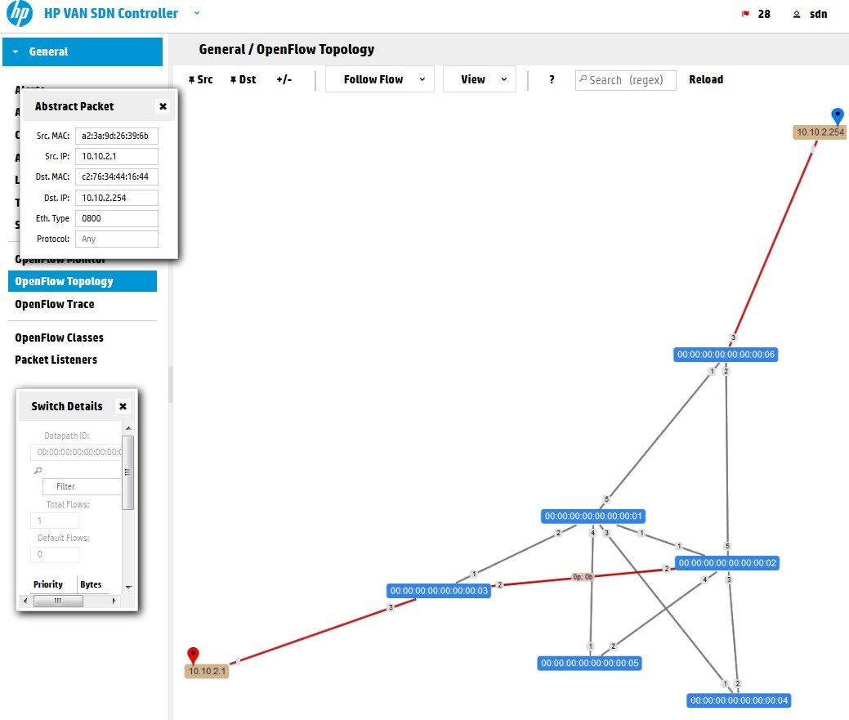
HP
VAN SDN Controller 2.4.6 – switch 3 redirected with our flow input

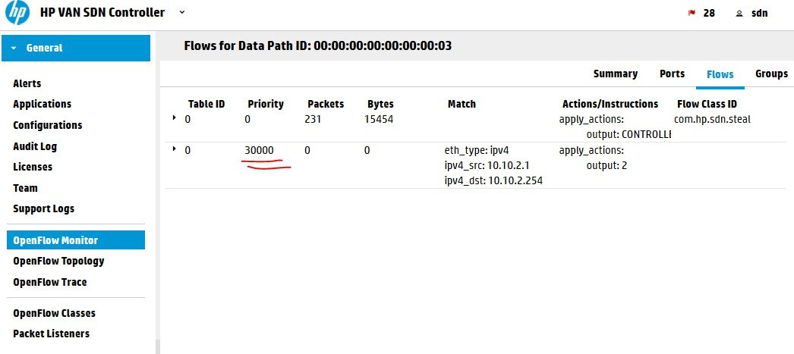
HP
VAN SDN Controller 2.4.6 – switch 3 flow table with manually added flow
However, the worst thing here is that if you now try to ping from H1 to G1 it will fail, the reason is that if we start doing this manually, we should do this end-to-end to satisfy connectivity. So let’s do just that ….

Step 4) Redirecting the ﬂow end to end
I will try to have some fun here, so bear with me and let’s forward make the path this way
H1->S3->S2->S5->S1->S6->G1 in a very funny loop :), but will demonstrate the power of what we are doing here. Here is the complete script, but really since I am choosing this path
manually there is no really added value logic to this to justify calling it a “script”. Just consider this a list of commands for each switch in this artificial path: #!/bin/bash
### SCRIPT TO REDIRECT H1-to-G1 via artificial path ### H1->S3->S2->S5->S1-G1

#S3 redirect
curl -ski -X POST \
-H "X-Auth-Token:`cat /tmp/SDNTOKEN`" \
-H "Content-Type:application/json" \
-d '{
"flow": {
"cookie": "0x2031987", "table_id": 0,
"priority": 30000,
"idle_timeout": 300,
"hard_timeout": 300, "match": [
{"ipv4_src": "10.10.2.1"},
{"ipv4_dst": "10.10.2.254"},
{"eth_type": "ipv4"}
],

2}]}]

}' \
"instructions": [{"apply_actions": [{"output":

}

https://192.168.125.9:8443/sdn/v2.0/of/datapaths/00:00:00:00:0 0:00:00:03/flows

#S2 redirect
curl -ski -X POST \
-H "X-Auth-Token:`cat /tmp/SDNTOKEN`" \
-H "Content-Type:application/json" \
-d '{
"flow": {
"cookie": "0x2031987", "table_id": 0,
"priority": 30000,
"idle_timeout": 300,
"hard_timeout": 300, "match": [
{"ipv4_src": "10.10.2.1"},
{"ipv4_dst": "10.10.2.254"},
{"eth_type": "ipv4"}

4}]}]

}' \
],
"instructions": [{"apply_actions": [{"output":

}

https://192.168.125.9:8443/sdn/v2.0/of/datapaths/00:00:00:00:0 0:00:00:02/flows

#S5 redirect
curl -ski -X POST \
-H "X-Auth-Token:`cat /tmp/SDNTOKEN`" \
-H "Content-Type:application/json" \
-d '{
"flow": {
"cookie": "0x2031987", "table_id": 0,
"priority": 30000,
"idle_timeout": 300,
"hard_timeout": 300, "match": [

{"ipv4_src": "10.10.2.1"},
{"ipv4_dst": "10.10.2.254"},
{"eth_type": "ipv4"}
],

1}]}]

}' \
"instructions": [{"apply_actions": [{"output":

}

https://192.168.125.9:8443/sdn/v2.0/of/datapaths/00:00:00:00:0 0:00:00:05/flows

#S1 redirect
curl -ski -X POST \
-H "X-Auth-Token:`cat /tmp/SDNTOKEN`" \
-H "Content-Type:application/json" \
-d '{
"flow": {
"cookie": "0x2031987", "table_id": 0,
"priority": 30000,
"idle_timeout": 300,
"hard_timeout": 300, "match": [
{"ipv4_src": "10.10.2.1"},
{"ipv4_dst": "10.10.2.254"},
{"eth_type": "ipv4"}

5}]}]

}' \
],
"instructions": [{"apply_actions": [{"output":

}

https://192.168.125.9:8443/sdn/v2.0/of/datapaths/00:00:00:00:0 0:00:00:01/flows

#S6 redirect
curl -ski -X POST \
-H "X-Auth-Token:`cat /tmp/SDNTOKEN`" \
-H "Content-Type:application/json" \
-d '{
"flow": {
"cookie": "0x2031987", "table_id": 0,

"priority": 30000,
"idle_timeout": 300,
"hard_timeout": 300, "match": [
{"ipv4_src": "10.10.2.1"},
{"ipv4_dst": "10.10.2.254"},
{"eth_type": "ipv4"}

3}]}]

}' \
],
"instructions": [{"apply_actions": [{"output":

}

https://192.168.125.9:8443/sdn/v2.0/of/datapaths/00:00:00:00:0 0:00:00:06/flows

When executing the above script, you should only get “201 Created” responses back. NOTE: If you want, you can avoid mixing JSON to the cURL command and simply add the JSON ﬂow definitions to a file and then call the cURL command -d parameter with the file
reference like this “-d @/file_with_ﬂow_definition.json” and you can limit this script amount of lines quite significantly.
Verification of routing is again via the SDN controller gui that should now in the OpenFlow topology show something like this (this is really great!):

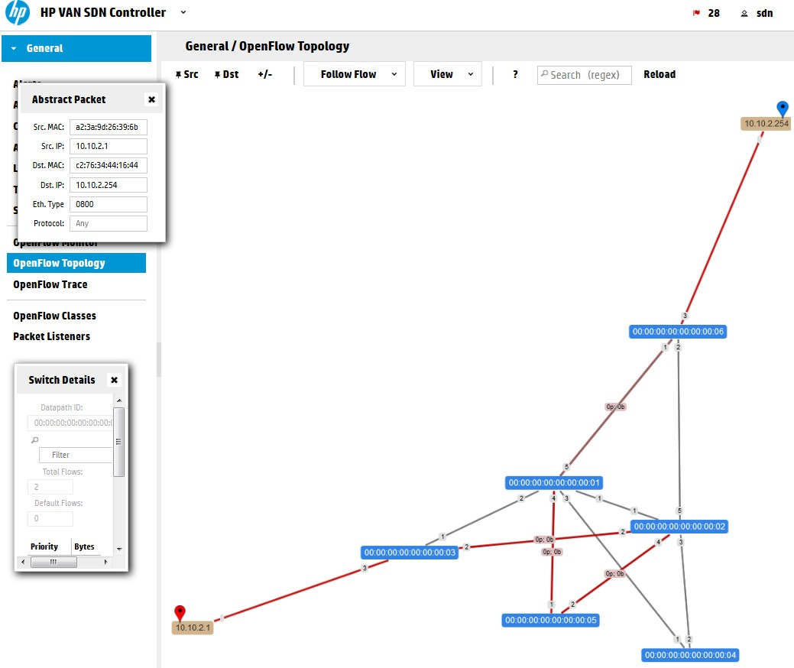
HP
VAN SDN Controller 2.4.6 – Complete redirection of L2 traffic in a loop from H1 to G1 via path of S3->S2->S5->S1->S6 switches
Additionally, the ping should work in this path in mininet now (also note that because the rules exist in advance, the first ping doesn’t have the usual increased delay until controller makes a routing decision):
mininet> h1 ping g1
PING 10.10.2.1 (10.10.2.1) 56(84) bytes of data.
64 bytes from 10.10.2.1: icmp_seq=1 ttl=64 time=0.026 ms
64 bytes from 10.10.2.1: icmp_seq=2 ttl=64 time=0.032 ms
64 bytes from 10.10.2.1: icmp_seq=3 ttl=64 time=0.041 ms
^C
--- 10.10.2.1 ping statistics ---
3 packets transmitted, 3 received, 0% packet loss, time 1999ms rtt min/avg/max/mdev = 0.026/0.033/0.041/0.006 ms

Step 5) Explicit removal of the ﬂows you just done

On one side you can just wait 300 seconds until the hard.timeout clears our ﬂows, but in real deployment you would definitely not used hard.timeout that often, so lets at the end look
how you can remove a ﬂow via REST API.
The easy/basic way is that you take the script shown in previous steps and only change the HTTP method from -X POST to -X DELETE and supply the same JSON description of the rule. That’s it:
curl -ski -X DELETE \
-H "X-Auth-Token:`cat /tmp/SDNTOKEN`" \
-H "Content-Type:application/json" \
-d '{
"flow": {
"cookie": "0x2031987", "table_id": 0,
"priority": 30000,
"idle_timeout": 300,
"hard_timeout": 300, "match": [
{"ipv4_src": "10.10.2.1"},
{"ipv4_dst": "10.10.2.254"},
{"eth_type": "ipv4"}

2}]}]

}' \
],
"instructions": [{"apply_actions": [{"output":

}

https://192.168.125.9:8443/sdn/v2.0/of/datapaths/00:00:00:00:0 0:00:00:03/flows

The correct code that should return is “204 No Content”.
The above method is however only valid for us here because we already have the JSON
description of exactly the rule we want to remove, in real application when you do not know this, you would normally search the ﬂows that exist using the REST API’s GET
/of/datapath/{dpid}/ﬂow, extract the JSON of a rule that you want removed from there
(maybe by searching for the cookie value we used to identify “our” ﬂows) and remove that.

Practical - 7
Aim : Create a network and run a simple performance test Creating Network
Open the Mininet terminal
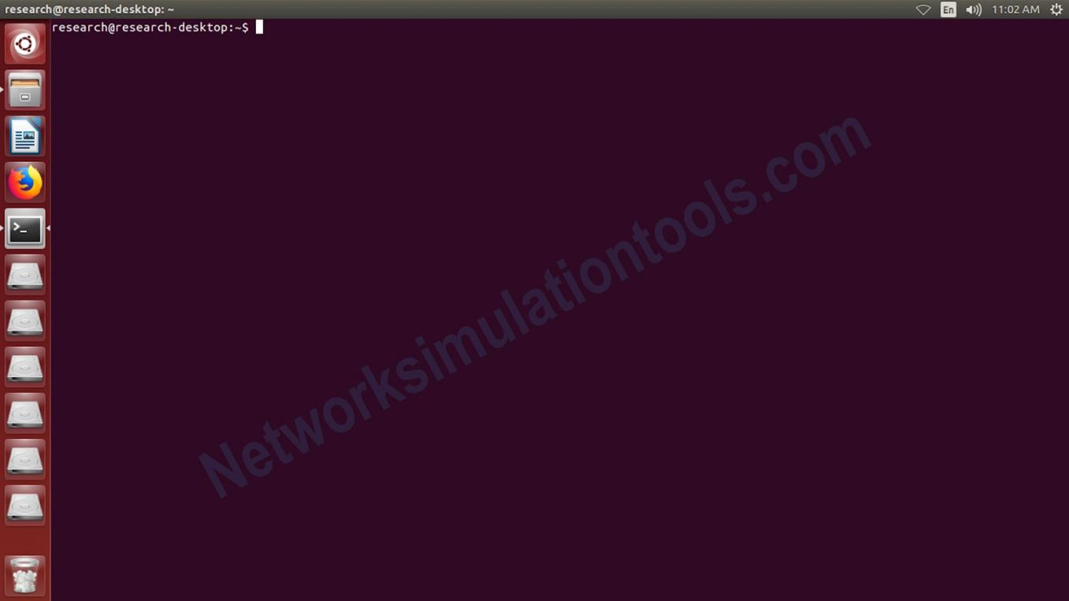
Initially, download and install the needed version of mininet . Next open the terminal by press ctrl+alt+T buttons or search from the installed software list.

Change the Mininet location
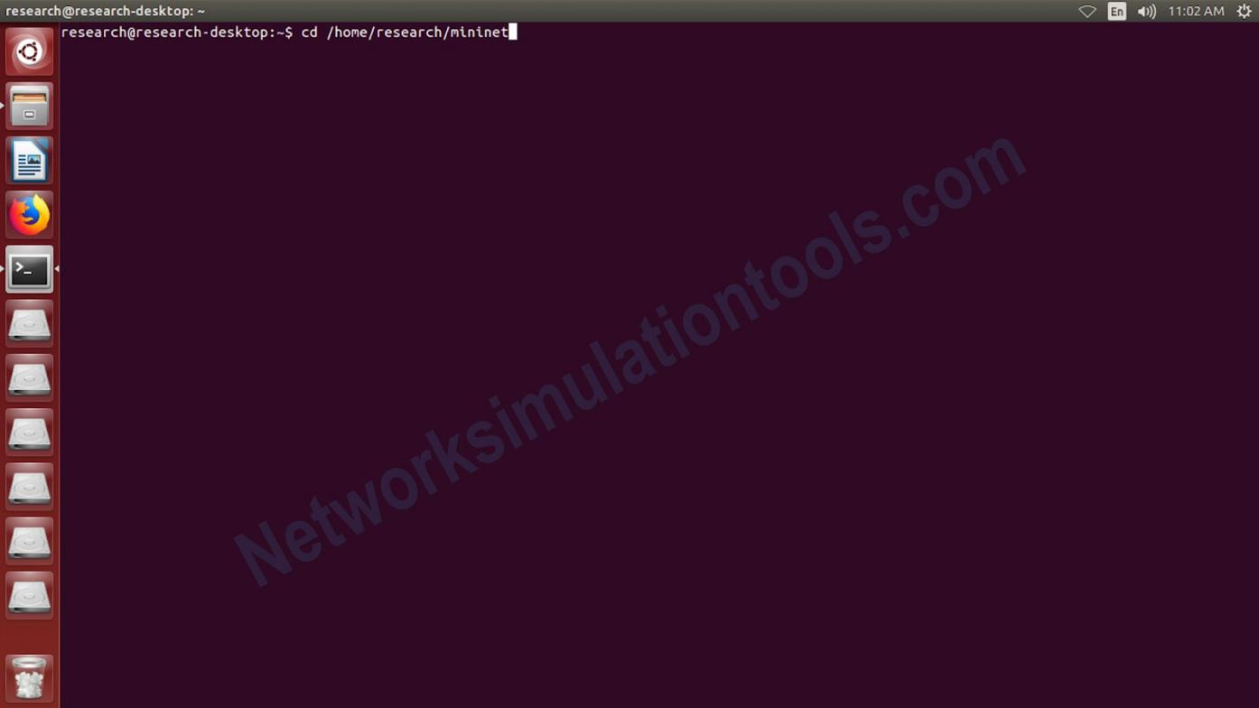
Change the mininet installed location by using the command cd. The location must have the main mininet executable file which is named as “./mininedit.py”.

Execute the Mininet command
Execute the main command “./mininedit.py” to get the simulation window. If the
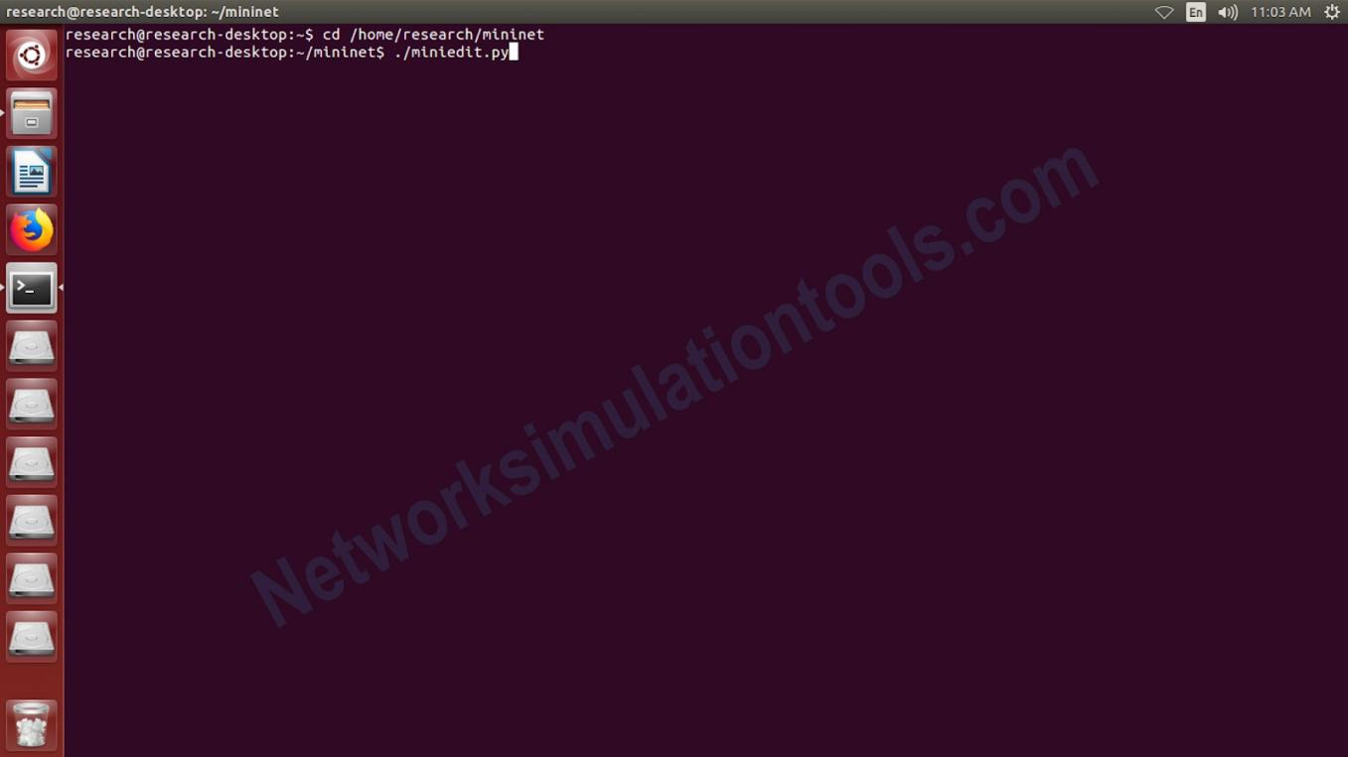
“./mininedit.py is not in the executable format, then change into executable format, by using the command sudo chmod +x mininedit.py

Construction the network
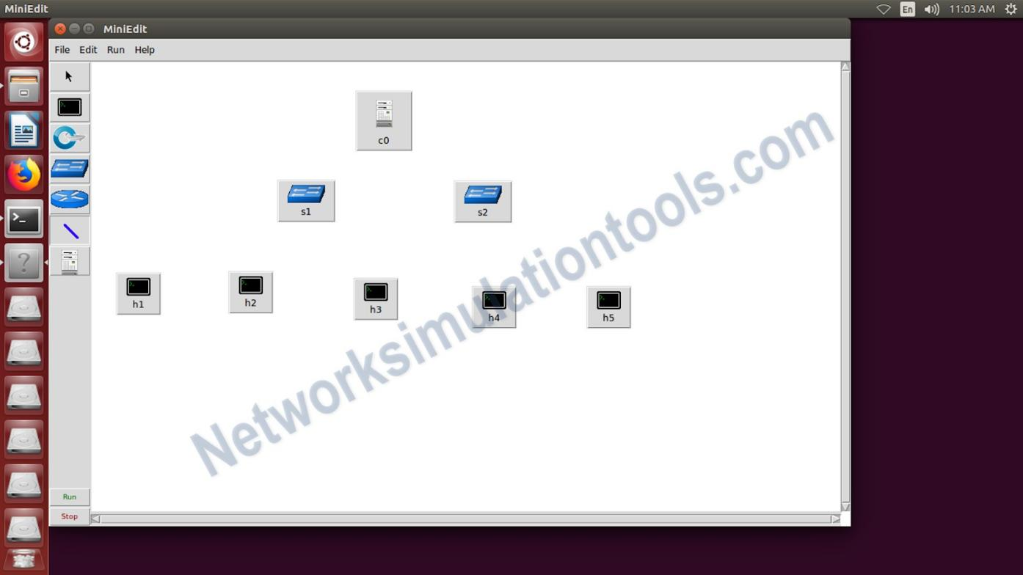
In the simulation window goto file menu and select the new project option. And construct the network . during the network construction click and track the needed nodes based on the node types. The types are like the controller,openﬂowswitch and host nodes.

Connect the Network Nodes
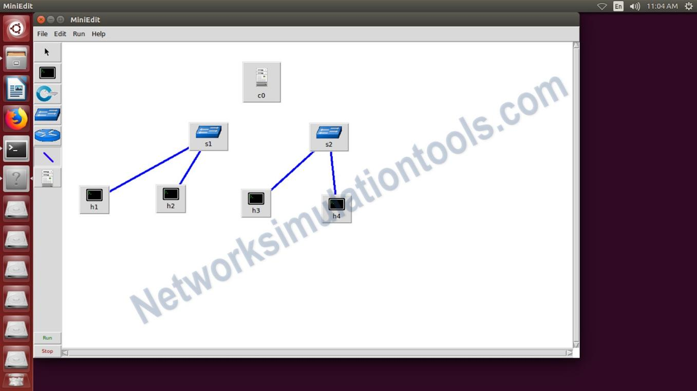
After construct the network , make connection between the nodes. By using the link components in the list, which is occurred in the left side.

Practical - 8
Aim : Mininet Random Topology Generator

[random_topology.c] #include <stdio.h>
#include <stdlib.h> #include <math.h> #include <string.h> #include <time.h>
#define True 1
#define False 0
int pick_to( int* closed, int vertices )
{
int vertex;

if ( closed == NULL ) /* pick any vertex, even if picked before... */ do {
vertex = ran( vertices );
} while ( vertex == 0 ); /* ...except for start */ else {
do {
vertex = ran( vertices );
} while ( closed[ vertex ] ); closed[ vertex ] = True;
}
return ( vertex );
}

int unpicked_vertices_p( int* closed, int n )
{
int i = 1;

while ( i < n )
if ( !closed[ i ] ) return ( True );
else
i++;
return ( False );
}

/*** ran, etc. ***/ void seed_ran( void )
{
srand( ( unsigned short ) time( NULL ) );
}

/* Return a random integer between 0 and k-1 inclusive. */ int ran( int k )

{
return rand() % k;
}

int main()
{
int N, E, H, i, j, index, selected_sw; int MaxBW;
FILE *fptr; char str[100];

int start = 0,
finish, from, to, edge_count = 0,
*adj_matrix,
*closed_list;

seed_ran();
printf("Number of switches:"); scanf("%d",&N);
printf("Number of links:"); scanf("%d",&E);
printf("Number of hosts:"); scanf("%d",&H);
printf("Maximum Bandwidth:"); scanf("%d", &MaxBW);
printf("N=%d E=%d H=%d MaxBW=%d\n", N, E, H, MaxBW); fptr=fopen("test_topology.py", "w");
if(!fptr) return 1;

finish=N-1; if (N==1) {

printf("SingleVertexNetwork\n"); return;
}

/* adjacency matrix to represent graph */
if((adj_matrix=(int *)calloc(N * N, sizeof(int)))==NULL) { printf("InsufficientStorage\n");
return;
}

/* closed_list[ i ] == True if vertices[ i ] is on some path from start to finish */ if((closed_list=(int *)calloc(N, sizeof(int)))==NULL) {
printf("InsufficientStorage\n"); free(adj_matrix);
return;
}

/* put each vertex on some path from start to finish */ closed_list[ start ] = True;
do {
/* from start to some vertex not already picked */ to = pick_to(closed_list, N);
adj_matrix[ to ] = ran( MaxBW ) + 1; edge_count++;

/* from current vertex to vertex != finish */ if ( to != finish ) {
from = to;
closed_list[ finish ] = False;
while ( ( to = pick_to( closed_list, N ) ) != finish ) { adj_matrix[ from * N + to ] = ran( MaxBW ) + 1; edge_count++;
from = to;
}

/* from vertex to finish */
adj_matrix[ from * N + finish ] = ran( MaxBW ) + 1; edge_count++;
}
} while ( unpicked_vertices_p( closed_list, N ) );

/* add additional edges as needed */ while ( edge_count < E ) {
from = ran( N - 1 );
to = pick_to( NULL, N );
if ( !adj_matrix[ from * N + to ] && from != to ) { adj_matrix[ from * N + to ] = ran( MaxBW ) + 1; edge_count++;
}
}

fprintf(fptr, "#!/usr/bin/python\n");
fprintf(fptr, "from mininet.net import Mininet\n");
fprintf(fptr, "from mininet.node import Controller, RemoteController, OVSKernelSwitch, UserSwitch\n");
fprintf(fptr, "from mininet.cli import CLI\n");
fprintf(fptr, "from mininet.log import setLogLevel\n"); fprintf(fptr, "from mininet.link import Link, TCLink\n"); fprintf(fptr, "\n\ndef topology():\n");
fprintf(fptr, " net = Mininet(controller=RemoteController, link=TCLink, switch=OVSKernelSwitch)\n");
//fprintf(fptr, " c0 = net.addController('c0', controller=Controller, ip='127.0.0.1', port=6633
)\n");
fprintf(fptr, " c0 = net.addController( 'c0', controller=RemoteController, ip='127.0.0.1', port=6633 )\n");
//fprintf(fptr, " s1 = net.addSwitch('s1', listenPort=6673, mac='00:00:00:00:00:01')\n");
//fprintf(fptr, " h1 = net.addHost('h1', mac='00:00:00:00:00:01', ip='10.0.0.1/24')\n");
//fprintf(fptr, " h2 = net.addHost('h2', mac='00:00:00:00:00:02', ip='10.0.0.2/24')\n");
//fprintf(fptr, " net.addLink(s1, h1)\n");
//fprintf(fptr, " net.addLink(s1, h2)\n");

for(i=1; i<=N; i++){
sprintf(str, " s%d = net.addSwitch('s%d')", i, i); fprintf(fptr, "%s\n", str);
}

for(i=1; i<=H; i++){
sprintf(str, " h%d = net.addHost('h%d')", i, i); fprintf(fptr, "%s\n", str);
selected_sw=(rand() % N) + 1;
sprintf(str," net.addLink(s%d, h%d, bw=%d)", selected_sw, i, MaxBW); fprintf(fptr, "%s\n", str);

}

for(i=1; i<N;i++) {
for (j=i+1;j<=N;j++) { index=(i-1)*N + j-1;
if(adj_matrix[index]){
//printf("%d %d %d\n", i, j, adj_matrix[index]);
sprintf(str," net.addLink(s%d, s%d, bw=%d)", i, j, adj_matrix[index]); fprintf(fptr, "%s\n", str);
}
}
}

fprintf(fptr, " net.build()\n"); fprintf(fptr, " c0.start()\n"); for(i=1; i<=N; i++){
sprintf(str, " s%d.start([c0])", i); fprintf(fptr, "%s\n", str);
}
fprintf(fptr, " CLI( net )\n"); fprintf(fptr, " net.stop()\n");

fprintf(fptr, "\n\nif name == ' main ':\n"); fprintf(fptr, " setLogLevel( 'info' )\n");

fprintf(fptr, " topology()\n"); fclose(fptr);
/* free storage */ free( adj_matrix ); free( closed_list ); return 0;
}

[usage]
- compile this program

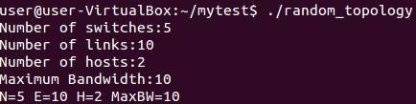
- execute the program

After execution, the program will generate a file, "test_topology.py" #!/usr/bin/python
from mininet.net import Mininet
from mininet.node import Controller, RemoteController, OVSKernelSwitch, UserSwitch from mininet.cli import CLI
from mininet.log import setLogLevel from mininet.link import Link, TCLink

def topology():
net = Mininet(controller=RemoteController, link=TCLink, switch=OVSKernelSwitch) c0 = net.addController( 'c0', controller=RemoteController, ip='127.0.0.1', port=6633 ) s1 = net.addSwitch('s1')
s2 = net.addSwitch('s2') s3 = net.addSwitch('s3') s4 = net.addSwitch('s4') s5 = net.addSwitch('s5') h1 = net.addHost('h1')
net.addLink(s4, h1, bw=10) h2 = net.addHost('h2')
net.addLink(s2, h2, bw=10) net.addLink(s1, s2, bw=3) net.addLink(s1, s3, bw=10) net.addLink(s1, s4, bw=6) net.addLink(s1, s5, bw=1) net.addLink(s2, s3, bw=3) net.addLink(s2, s5, bw=6) net.addLink(s3, s4, bw=10) net.addLink(s3, s5, bw=8) net.addLink(s4, s5, bw=9) net.build()
c0.start() s1.start([c0])
s2.start([c0])

s3.start([c0])
s4.start([c0])
s5.start([c0]) CLI( net )
net.stop()

if name == ' main ':
setLogLevel( 'info' ) topology()

- test the mininet script.
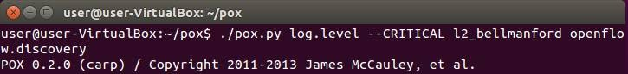
  - run the controller that can ﬁnd the shortest path from source to destion.

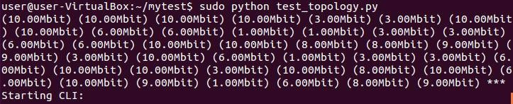
  - run the mininet script

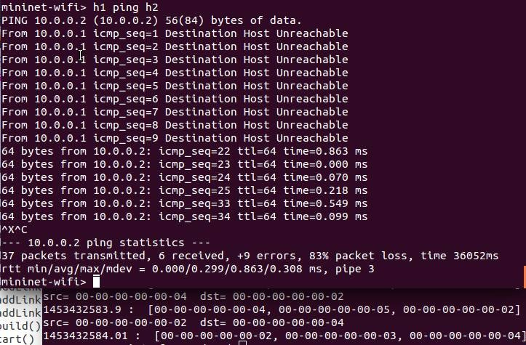
  - try to ﬁnd the path from h1 to h2. (h1 is connected to s4 and h2 is connected to s2)

